**Storytelling with Data**

**Exercise**

In this exercise, you will apply your knowledge of data visualization to create a data visualization based on the given longitudinal data for three different indicators from Tanzania DHS surveys. You will be required to select one or two indicators or use selected years for chosen indicators. You **cannot** use ALL of this data. You can choose what data to select, as long as you do not use all data points for all three indicators.

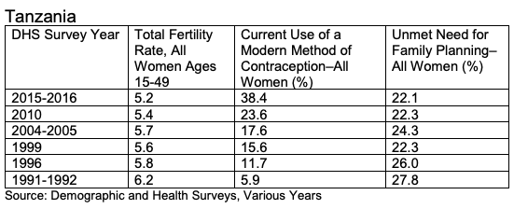

Together with your peer, you will create a visualization using the selected data. You will be required to create your visualization using google sheets, slides or by freehand drawing. Once you’re done, you will have two minutes to present your visualization to another peer group. Your peer can use this rubric [[Link](http://stephanieevergreen.com/wp-content/uploads/2014/05/DataVizChecklist_May2014.pdf)] for grading.

Your goal will be to increase understanding of your data and use the data to tell a story while applying principles of good data visualization. You may want to use the given guidelines to begin planning your data visualization.

Guidelines:

1. Topic:
2. Audience:
3. Communication Objective:
4. What’s the story in my data?
5. Why am I using data visualization to explain this story?
6. What colors (if any) have symbolic meaning—both positive and negative—for this topic?
7. What are some icons or images that have symbolic meaning for this topic?
8. What type of graph can convey this data?